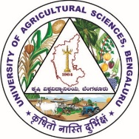 | 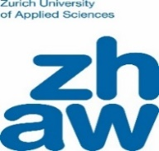 |  | 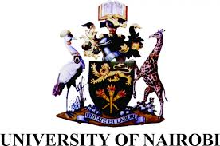
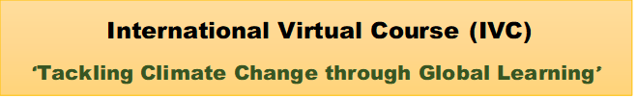
Course Coordinator: Dr. K. B. Umesh
A collaborative international academic programme ‘International Virtual Course’ (IVC) has been started in the University during 2020 and it is first of its kind not only in this University may be even among all the State Agricultural Universities in India. The IVC is a joint collaborative programme of four Universities viz., Zurich University of Applied Sciences (ZHAW), Switzerland, Federal University of Grande Dourados (UFGD), Brazil, University of Nairobi, Kenya and University of Agricultural Sciences, Bangalore (UASB). The programme partnership agreement signed on 10th March, 2020. The partnership represents four continents (Europe, South America, Africa and Asia).
The theme of IVC is “Tackling Climate Change through Global Learning”. The course deals with the impacts and challenges of climate change as well as strategies for adaptation and mitigation in different geographical contexts and on a global level. This interdisciplinary course is aimed at students of agriculture sciences and environmental sciences from the four universities. Ten students from each partner institutions will be selected every year based on the topic of interest and motivation. In addition to their specialist skills, student’s skill will be strengthened through international learning in digitization and intercultural cooperation. Students will be trained to become global change makers. The learning by the students under this programme is a hybrid of both online and offline. Dissemination of information/lectures by the international experts and international case study groups will be through online. This programme is expected to open up a new vista in addressing the global climate change related issues.
This joint academic programme is funded by Movetia (Swiss agency for exchange and mobility) & Mercator Foundation Switzerland for a period of five years (2020-2024).
Learning objectives:
1. To describe the impacts of climate change focusing on agro food systems and to develop innovative solution strategies
2. To correctly apply virtual collaboration tools (Zoom, Whatsapp, Jamboard etc.)
3. To collaborate effectively across cultural borders via virtual channels
4. To strengthen the skills through international learning in digitalization and intercultural cooperation
5. To address the global climate change and other emerging issues
6. To enhance knowledge on climate change through lectures, case studies and discussions by international experts
Course credits and content:
The duration of IVC programme is about 14 weeks (120 hours of workload) consisting of 4 phases, Viz., climate change at local perspective (phase I), virtual class room (phase II), virtual team work (phase III) and reflection (phase IV). The course enables the students to earn 4 ECTS (European Credit Transfer System) [≈ 4 credit hours] based on three work performance: 1) video film making 2) Report of the virtual group work and presentation 3) Reflection report.
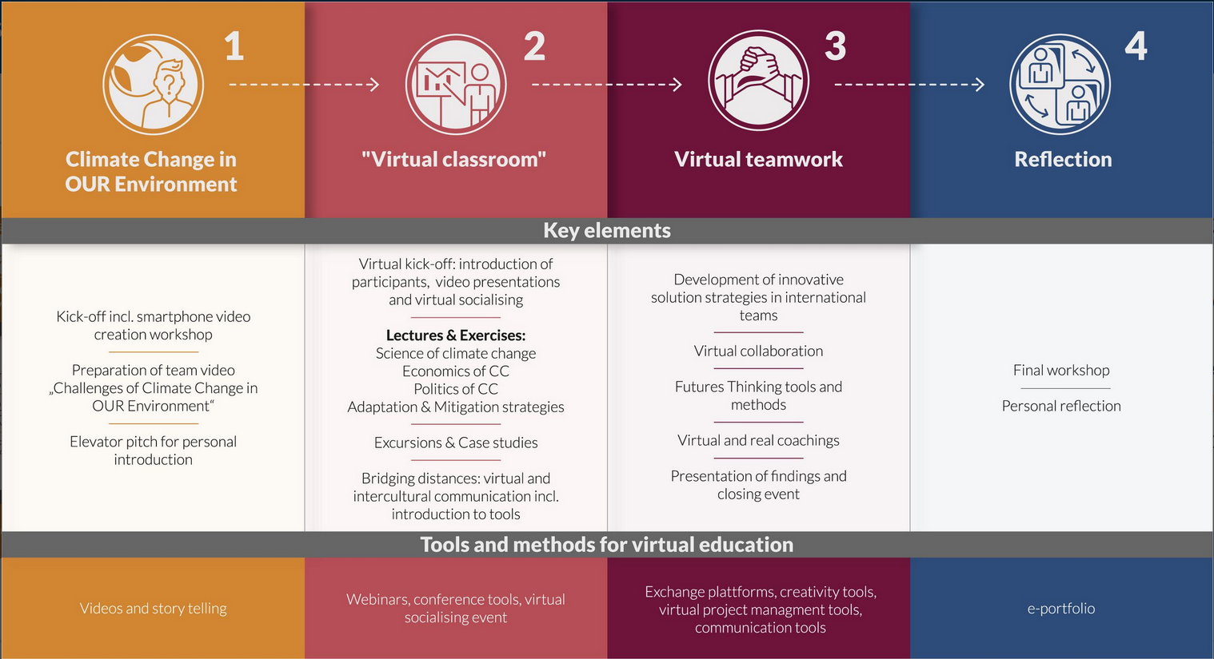
Phase I: Climate change at local perspective (30 hours)
The main objective of this module is to learn and understand climate change related issues in our local environment and cross country exchange of the climate change issues. In this module, students will be trained for the identification of problem and video making by the experts through a short course/ workshop. The video prepared by the students from four countries will cover the aspects of climate change and how it is affecting their country in particular and Global in a larger context. The duration of the video is about 10 minutes and the video prepared in this phase will be exchanged with students of other countries in the beginning of Phase II. This video will also serve in choosing an appropriate research question to be focused in Phase III i.e. Virtual team work. In order to gain knowledge on climate change, students are required to complete two-part e-Learning before phase II starts. The first part consists of the FAO course “Introduction to climate-smart agriculture”. The second part consists of another FAO course of student’s choice. However, for second part, few topics have been identified viz Climate-smart crop production, Climate-smart fisheries and aquaculture, Climate-smart forestry, Climate-smart livestock production, Climate-smart soil and land management, Water management for climate-smart agriculture.
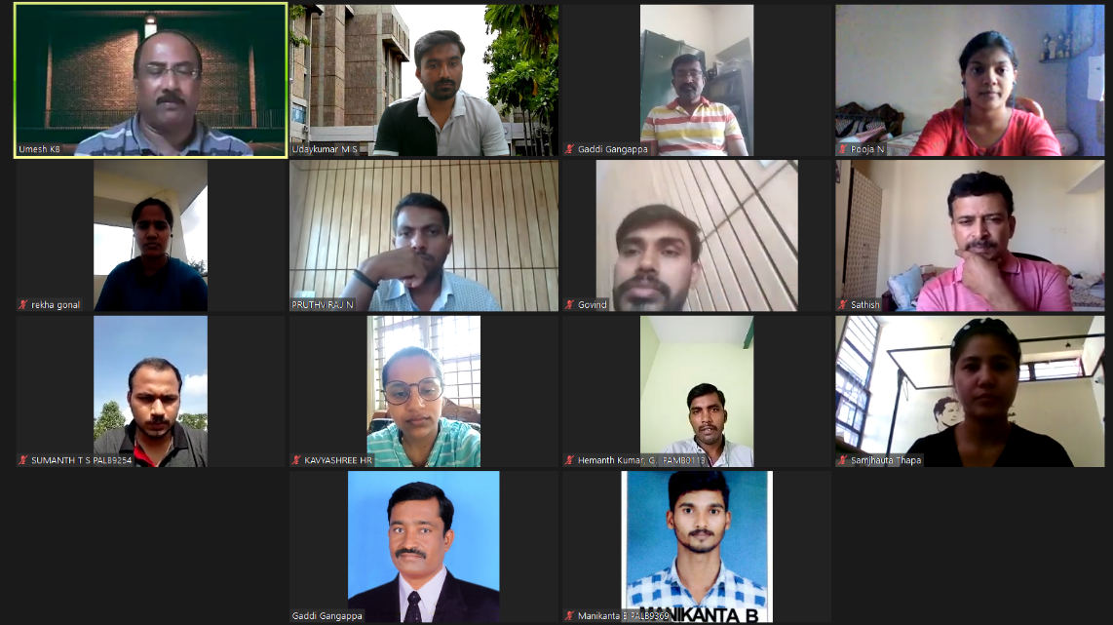
Introductory lectures on climate change
Phase II: Virtual classroom (40 hours)
The video prepared in Phase I will be presented during this phase. This phase mainly focused on lectures from experts of climate change across the globe. During this phase, students, mentors and invited experts will meet almost every day for 90 minutes virtually. This provides an opportunity for the students to interact, discuss and exchange ideas on climate change as well as current ongoing challenges. International panel discussions on climate change adaptation and mitigation aspects will be part of this phase. The students will also undergo the examination on FAO e-learning. This phase expands the knowledge horizon of the students about climate change. During this phase student will be taken for exposure visits to the climate affected areas.
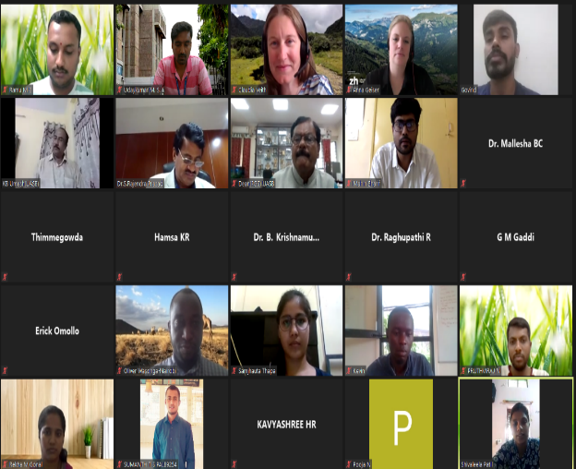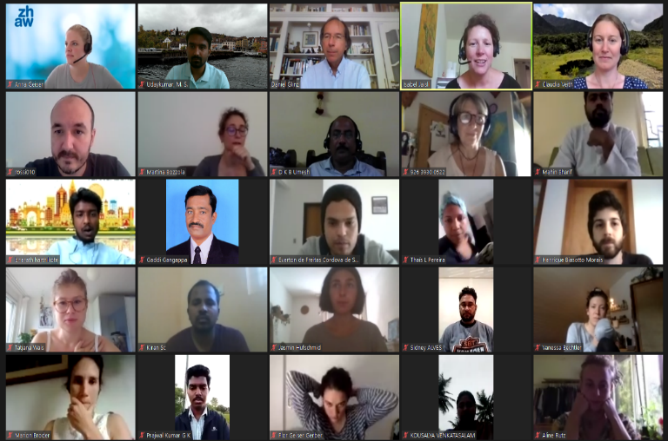
International Kick-off and virtual classes
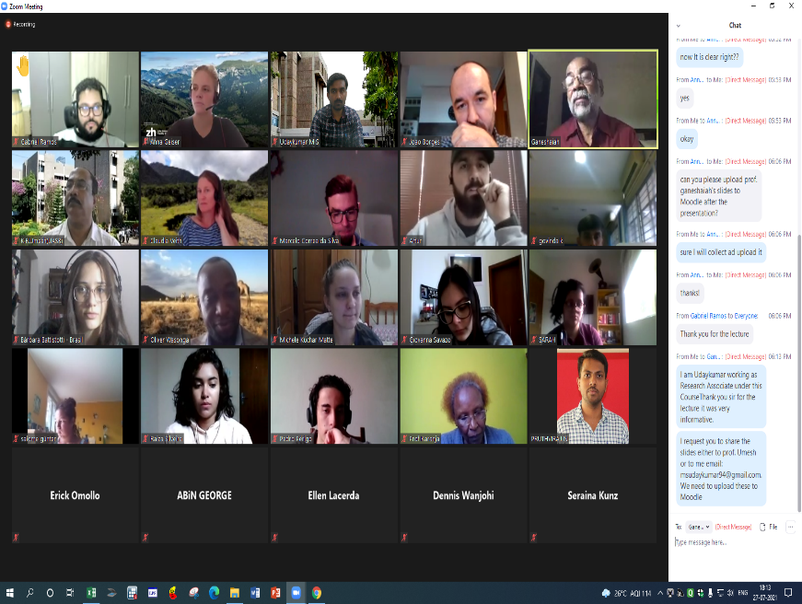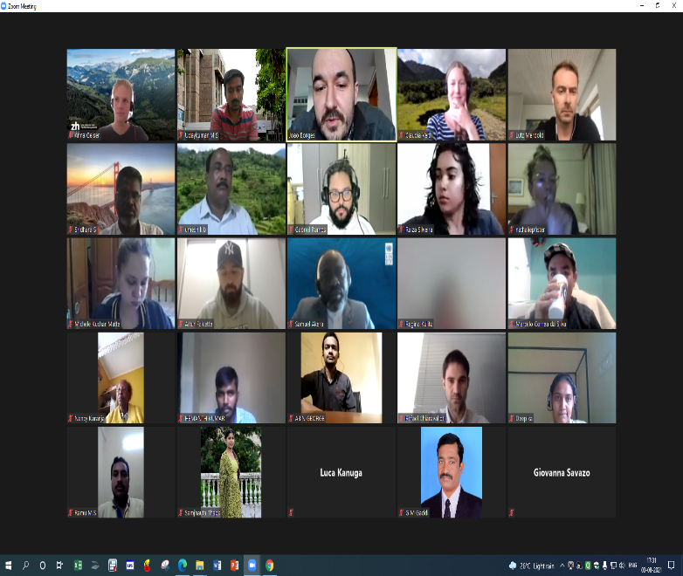
Panel discussions and lectures from international experts
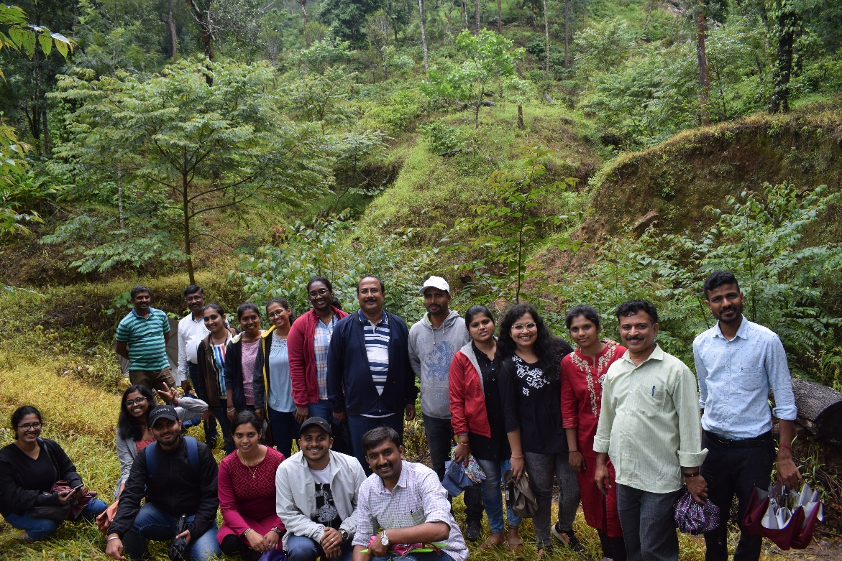
Field excursion to climate change affected areas
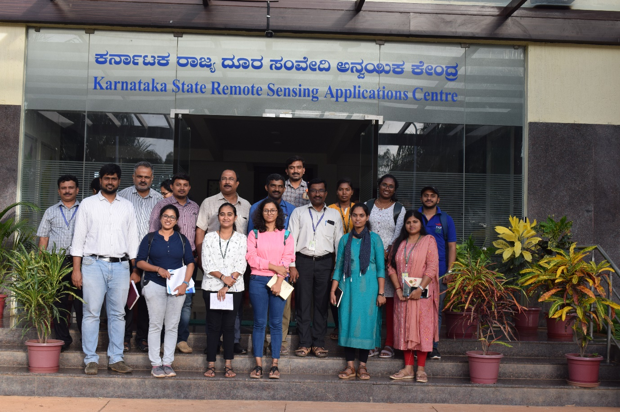
Insttutional Visit Under International Virtual Course

Phase III: Virtual team work (40 hours)
International group work is the core of phase III. Students will be grouped into International teams consisting of one student from each country. The group will discuss together among themselves and with mentors and will write a proposal on innovative solution strategies for a specific issue related to climate change. Each team will have their own coach and meet with them for up to five times. In between, it is up to the group to meet with their international peers and collaborate virtually to evolve of innovative solution strategies. At the end of phase III, each group will have a chance to present their work and discuss with the other participants. 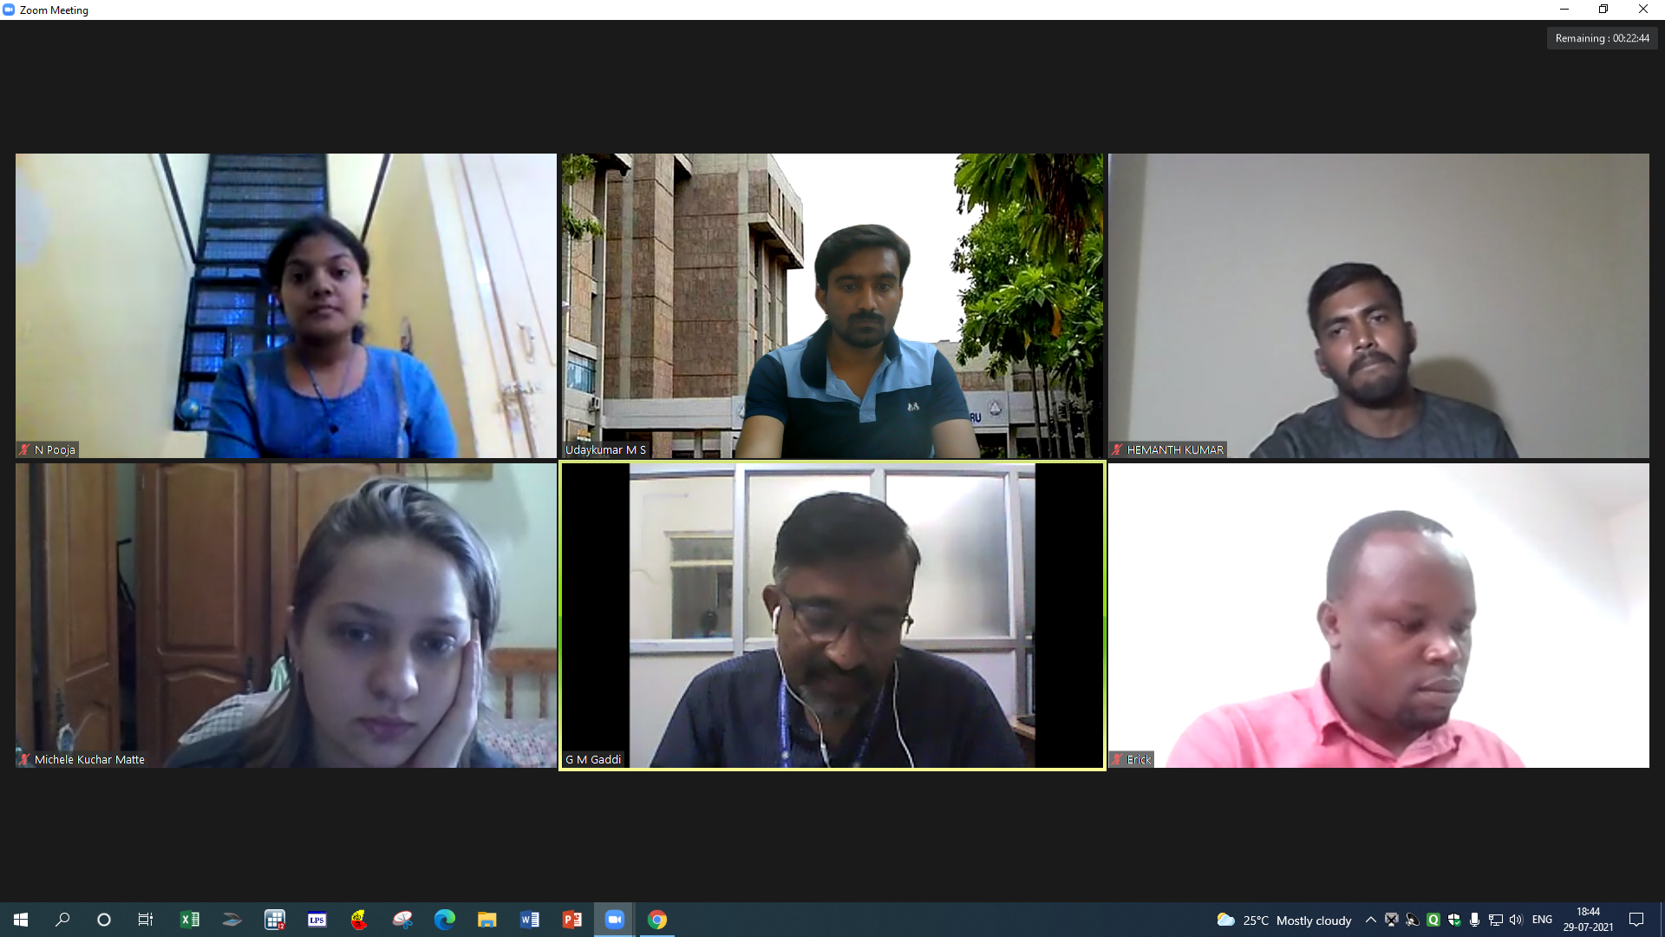
Virtual Team Work in International Groups
Phase IV: Reflection (10 hours)
This phase is mainly to evalaue the course content and structure. Opinion for further improvement will be collected from the participants. Reflection of virtual and intercultural collaboration is the main objective of this phase. Evaluating the virtual tools, all the phases, co-operation on eye-level and overall project evaluation will be done in this phase. Final debriefing and certificate distribution programme will be organized at the end of this phase where students and the mentors will be awarded with valuable certificate.
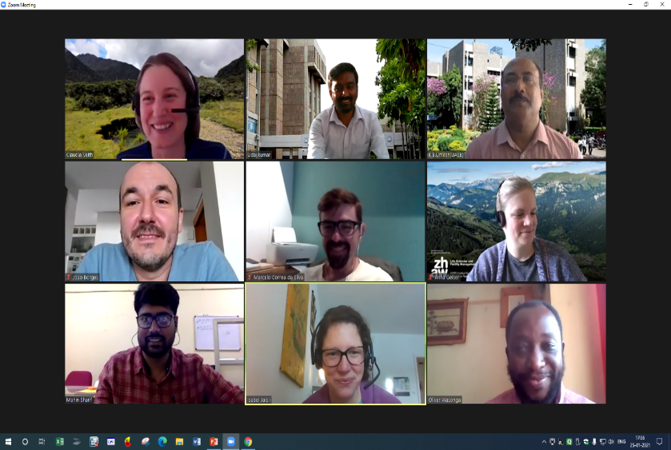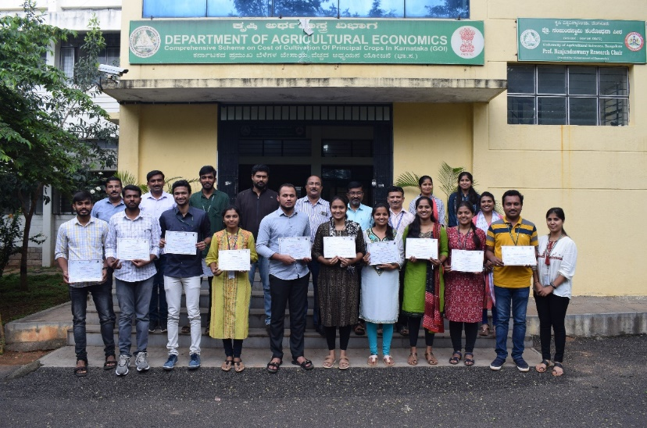
Debriefing and Certificate distribution
Benefits from Virtual course -Take home
- International exposure
- Working experience with international Universities/students and faculty with different language, culture, environment, etc.
- Exposure to different knowledge domain via sharing individual’s ideas
- Emergence of creative and innovative ideas
- Strengthening of skills through international learning in digitalization and intercultural cooperation
- International Course Certificate with 4 ECTS (European Credit Transfer System) which is equivalent to 4 credit hours (UASB)
- Students can become global change maker - by understanding and addressing the global climate related and other emerging aspects.
Way forward- Knowledge sharing
- Associate with upcoming virtual course as mentor/guide
- Society: Associate with the NGO’s, Institutions working on climate change aspects
- Research: Prepare research proposals and aim for international collaboration
- Education: Actively involve in creating public awareness on climate change mitigation and adaptation.
Faculty associated with IVC 2021 from UASB
Sl. No. | Name | Role
1 | Dr. K. B. Umesh | Coordinator
2 | Dr. Mahin Sharif | Associate Coordinator
3 | Dr. M. N. Thimme Gowda | Mentor
4 | Dr. G. M. Gaddi | Mentor
5 | Dr. A. Sathish | Mentor
6 | Dr. Udaykumar, M. S. | Research Associate

International Virtual Course channel link
https://www.youtube.com/channel/UC9IlTE9JYTKk6h83ICk_BuA
Videos prepared under International Virtual Course
- Climate change in Our Environment Video (IVC 2020) link
https://www.youtube.com/watch?v=H5O0Z5e3lHA&t=8s
- Climate change in Our Environment Video (IVC 2021) link- Climate change and Biodiversity
https://youtu.be/lfK1Z86QJfc
- Climate change in Our Environment Video (IVC 2021) link- Climate change and Biodiversity
https://www.youtube.com/watch?v=G22-ky867Oo

Note: For details please visit UAS Bangalore website (https://www.uasbangalore.edu.in)
Contact: Dr. Udaykumar, M. S., Research Associate
Email: msudaykumar94@gmail.com Ph. No.: 9448968695

